FCHT - FCHT - Assignment to Payment

Functionality
This function allows you to allocate checks to different payment document. If the numbered checks are allocated to the wrong payments (for example, because the checks were fed into the printer in the wrong order), you can reallocate the checks to the correct payments before sending them out.

Scenario
A manual check was assigned to a wrong payment document. You need now to change the assignment.

Requirements
Posted checks with payment.

Menu Path | Accounting → Financial Accounting → Accounts Payable → Environment → Check information → Change → FCHT - Assignment to payment
Transaction Code | FCHT

1. Double click on FCHT - Assignment to payment.

Change Assignment of Checks to Payments

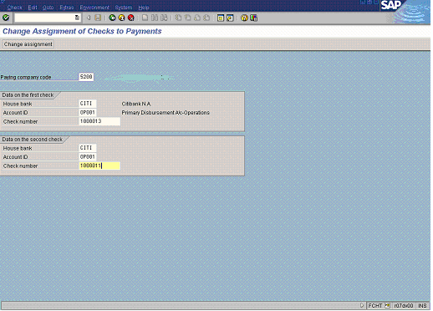

2. Update the following fields:

Field Name | Field Description | Values
House bank | Identification number for the house bank to which the transaction corresponds | Example: CITI
Account ID | This ID together with the ID for the house bank uniquely defines a bank account. | Example: OP001
Check number | A unique check number per company code, bank, and account number. You enter this check number in the check number file (under a so-called lot in which the check is contained). When the checks are used, the check information is stored in the payment transfer medium file. | Example: 1000013
House bank | Identification number for the house bank to which the transaction corresponds | Example: CITI
Account ID | This ID together with the ID for the house bank uniquely defines a bank account. | Example: OP001
Check number | Second check number. This is the check number you want to relocate a payment document to. | Example: 1000011

3. Click Enter Button to confirm your entries.

4. To change the allocation , click Change assignment Button .

5. The message bar displays “Check info for 1000013 and 1000011 reallocated”.

